**Image Tagger**

1. Splash Screen



This screen checks whether any data is existed in local db and if yes then pushes it to server

1. Home-Screen

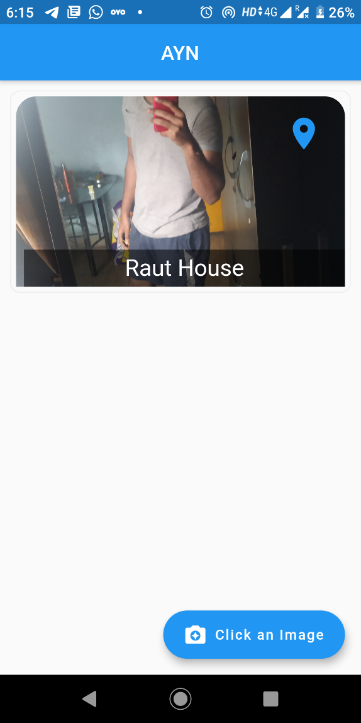

Image can be previewed by tapping on the image and to navigate yourself to the location by tapping on the location icon on the top right side of image, at the bottom of the image we can see the place name where we clicked the image.

There is a Floating action button by which we can click an image.

**NOTE**

Based on the internet connectivity the image is uploaded over the local db or server (local host)

Thank You

Karan Gore.